Mozambique

## Freedom House political status

The data set shows the Freedom House political scores and status of the country each year.

## # A tibble: 19 x 5  
## country iso3c date mean status   
## <chr> <chr> <dbl> <dbl> <chr>   
## 1 Mozambique MOZ 1996 3.5 Partly Free  
## 2 Mozambique MOZ 1998 3.5 Partly Free  
## 3 Mozambique MOZ 2000 3.5 Partly Free  
## 4 Mozambique MOZ 2002 3.5 Partly Free  
## 5 Mozambique MOZ 2003 3.5 Partly Free  
## 6 Mozambique MOZ 2004 3.5 Partly Free  
## 7 Mozambique MOZ 2005 3.5 Partly Free  
## 8 Mozambique MOZ 2006 3.5 Partly Free  
## 9 Mozambique MOZ 2007 3 Partly Free  
## 10 Mozambique MOZ 2008 3 Partly Free  
## 11 Mozambique MOZ 2009 3.5 Partly Free  
## 12 Mozambique MOZ 2010 3.5 Partly Free  
## 13 Mozambique MOZ 2011 3.5 Partly Free  
## 14 Mozambique MOZ 2012 3.5 Partly Free  
## 15 Mozambique MOZ 2013 3.5 Partly Free  
## 16 Mozambique MOZ 2014 3.5 Partly Free  
## 17 Mozambique MOZ 2015 4 Partly Free  
## 18 Mozambique MOZ 2016 4 Partly Free  
## 19 Mozambique MOZ 2017 4 Partly Free

## Freedom House classification of political change

The data set shows the GDP growth and the ecomic growth classification of the country each year.

## # A tibble: 19 x 4  
## country iso3c date politicalChangeFH  
## <chr> <chr> <dbl> <chr>   
## 1 Mozambique MOZ 1996 no change   
## 2 Mozambique MOZ 1998 no change   
## 3 Mozambique MOZ 2000 no change   
## 4 Mozambique MOZ 2002 no change   
## 5 Mozambique MOZ 2003 no change   
## 6 Mozambique MOZ 2004 no change   
## 7 Mozambique MOZ 2005 no change   
## 8 Mozambique MOZ 2006 no change   
## 9 Mozambique MOZ 2007 democratization   
## 10 Mozambique MOZ 2008 no change   
## 11 Mozambique MOZ 2009 autocratization   
## 12 Mozambique MOZ 2010 no change   
## 13 Mozambique MOZ 2011 no change   
## 14 Mozambique MOZ 2012 no change   
## 15 Mozambique MOZ 2013 no change   
## 16 Mozambique MOZ 2014 no change   
## 17 Mozambique MOZ 2015 autocratization   
## 18 Mozambique MOZ 2016 no change   
## 19 Mozambique MOZ 2017 no change

## Freedom House score trend

The plot shows the Freedom House scores trend of the country.

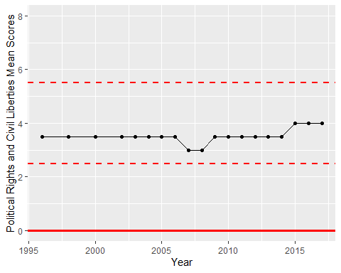

Freedom House Score Trend